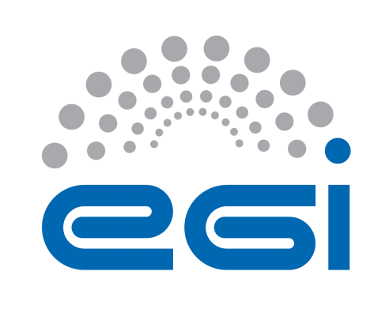
EGI-Engage

Report on the installed LifeWatch applications and their usage record
D6.18

Date | 1 February 2017
Activity | WP6
Lead Partner | CSIC
Document Status | DRAFT
Document Link | https://documents.egi.eu/document/XXX

Abstract
The LifeWatch EGI-Engage Competence Center is oriented to capture and address the requirements of Biodiversity and Ecosystems research communities, and promote their usage of EGI e-infrastructure. In this report we summarize the applications that have been integrated and installed on EGI by the LifeWatch Competence Centre, propose an initial description as services and associated information and metrics, and provide initial statistics about their use.

COPYRIGHT NOTICE

This work by Parties of the EGI-Engage Consortium is licensed under a Creative Commons Attribution 4.0 International License (http://creativecommons.org/licenses/by/4.0/). The EGI-Engage project is co-funded by the European Union Horizon 2020 programme under grant number 654142.
DELIVERY SLIP
 | Name | Partner/Activity | Date
From: | Jesus Marco | CSIC/SA2 | 1 Feb 2017
Moderated by:
Reviewed by
Approved by: | AMB and PMB

DOCUMENT LOG
Issue | Date | Comment | Author/Partner
v0.1 | 23/07/2016 | First draft | J. Marco/CSIC
v0.2 | 23/10/2016 | Scheme to report on services organized into cloud layers, roles, etc. | J. Marco, A. Lopez, E. Fernández, F. Aguilar (CSIC)
v0.3 | 6/12/2016 | Draft including an example on Ecological Observatories and Models (ALGAEBLOOM) and another on Workflow (TRUFA) | J. Marco, F. Aguilar (CSIC)
v0.4 | 22/12/2016 | Inputs from different case studies included | All (names to be included)
v0.5 | 15/01/2017 | First metrics included | All (names to be included)
v0.6 | 25/01/2017 | Version revised and proposed for delivery distributed within EGI-Engage LW CC | J. Marco/CSIC
v1.0 | 1/02/2017 | Version ready for internal review | J. Marco/CSIC
v1.1 | 15/02/2017 | Version including reviewers’ suggestions | J. Marco/CSIC
v1.2 | 27/02/2017 | Statistics of usage updated | J. Marco/CSIC
v2.0 | 28/02/2017 | Version ready for submission to EC | J. Marco/CSIC

TERMINOLOGY
A complete project glossary is provided at the following page: http://www.egi.eu/about/glossary/

Contents
1 Introduction 5
Case Studies considered 5
e-Infrastructures Services 6
Monitoring the use of LifeWatch applications in FedCloud resources 7
Summary of Applications, Users and Resources? Lifewatch VO??? 7
2 Description of applications in a service oriented Cloud framework 9
A service oriented Cloud scheme 9
A catalogue of services related to EU e-infrastructures 9
A detailed example 10
3 Services description 12
Introducing a template 12
Summary of common features in the different services 14
4 Service architecture (check previous deliverable, rewrite) 15
High-Level Service architecture oriented to the Cloud framework 15
Challenges 17
AAI 18
Access to data 19
Repositories 19
5 Monitoring/Impact/Feedback on satisfaction? 21
Experience at IFCA 21
Experience at VLIZ 22
Experience at HCMR 22
6 Summary 23
Appendix: Templates for the services 24

Executive summary
The goal of the LifeWatch EGI-Engage Competence Center (LW-EGI-CC) is to capture and address the requirements of Biodiversity and Ecosystems research communities. To achieve this goal, the LW-EGI-CC has been working on the definition, development and deployment of the Cloud and GPGPU based e-Infrastructure services that are required to support data management, data processing and modelling for Ecological Observatories….
In this report we summarize the applications that have been integrated and installed on EGI by the LifeWatch Competence Centre, propose an initial description as services and associated information and metrics, and provide initial statistics about their use.
A common template is proposed to be used to describe the services, based on a three-layered Cloud approach (IaaS, PaaS and SaaS), and following the definition used within the EGI FedCloud framework.
The list of applications considered includes:
- Applications related to ecological observatories, in particular those implemented to support the Research Vessel Simon Stevin, as part of the Flanders Marine LifeWatch Observatory, the monitoring and modelling system for the Cuerda del Pozo water reservoir in Spain, …
- Workflows supporting genomic analysis, like Galaxy and TRUFA
- Frameworks and applications oriented to Citizen Science, like Natusfera, or the automatic image recognition using Deep NN and exploiting GPUs.
- Virtual Research Environments, and integrated applications: Marine VRE and Terrestrial VRE
- General analysis and support tools, like R, Jupyter, ESA Earth Observation tools, GeoServer, …. (technical workgroups)
The report also complies the first statistics on the usage and impact of these applications…

- Introduction
The EGI-Engage LifeWatch Competence Center has analyzed along the last 20 months different Case Studies in the area of Biodiversity and Ecosystems Research.
Even if a limited number of Case Studies have been considered, and aiming mainly to the exploitation of the EGI framework, it is now time to consider a mid-term perspective and consider which services have been identified in these Case Studies as relevant for the Research Community, and verify that this is true based on statistics of its use and also the satisfaction of the researchers.
In this deliverable we aim to quantitatively report on the experience in the period covered by the last fourth months, November-February. But we will also have in mind the potential future exploitation in the framework of the European Open Science Cloud.
LifeWatch, as an e-infrastructure ESFRI, is considering its role in this context, and has started to analyze this “ecosystem” of services, as it has been described in the HLEG report released in October 2016.
In fact, in order to consider the interest and sustainability of the different services identified in this Competence Center, we need to analyze their dependency on other services, and also how they can be of interest to other communities, or shared with them.
This initial analysis of this ecosystem of services does not aim to be complete or formal, but it is necessary to understand in realistic terms the complexity of the EOSC ecosystem, and at the same time realize what is its potential.

Case Studies considered
We will restrict the analysis mainly to the “e-infra” services that LifeWatch researchers need, although sometimes the “e-infra” border is not clear. We will also restrict mainly to the three wide topics proposed in this Competence Center: Ecological Observatories, Workflows and Citizen Science, but we will consider within them the different Case Studies.
Case Study | Area | User Stories | “Services” identified
VRE marine | Ecological Observatories | Ship  R
VRE terrestrial | Ecolo
Water reservoir
OSN
Galaxy
TRUFA
Natusfera

e-Infrastructures Services
We will review some of the services offered by EGI.eu, and compare them to other e-Infrastructures, at many different levels
EGI catalogue of services

Ecological Observatories are one of the key data providers for LifeWatch, and a clear objective of the LifeWatch EGI Competence Center (LW-EGI-CC) is to integrate the tools required to support data management, data processing and modelling for Ecological Observatories in the framework provided by EGI.eu. To achieve this objective, several Case Studies directly related to on-going LifeWatch initiatives that require the manipulation of data streams from different Ecological Observatories have been considered and analysed.
Ecological Observatories data processes require today more and more "Big Data" techniques, from support to real-time data streams to handling the post-processing of large volumes of diverse data from multiple disciplines: meteorology, geophysics, hydrology, chemistry, social and of course life sciences (biology, ecology, -omics). Moreover, in the last years new and powerful software packages are starting to allow also the simulation of these complex multidisciplinary systems.
The LW-EGI-CC promotes the use of the EGI FedCloud as a common e-infrastructure to the different related initiatives, as it has been adopted as a basic platform for distributed e-infrastructure by the LifeWatch initiative, offering both the (substantial) resources required and also the possibility to test and install Cloud solutions at SaaS, PaaS and IaaS level. The LifeWatch Virtual Organization (LW-VO) is used to support this work, and as explained later, different roles are supported using different authentication and authorization mechanisms. Different FedCloud sites are supporting now the LW-VO, in particular the site at IFCA (Instituto de Fisica de Cantabria, CSIC-University of Cantabria), and the new site at EBD (Estacion Biologica de Doñana, CSIC) offer relevant computing and storage cloud enabled resources, at the different IaaS (Infrastructure as a Service), PaaS (Platforma as a Service) and SaaS (Solution/Software as a Service) levels.

Monitoring the use of LifeWatch applications in FedCloud resources
METRICS:
Description
How they are collected.
KPI???
Within the FEDCLOUD framework the following common metrics can be used to monitor the usage
Development: OpenProject and github…
Reports from the teams, publications, presentations at…

Summary of Applications, Users and Resources? Lifewatch VO???
Within this LW-EGI-CC framework, and in order to analyze how to offer an adequate support to the researchers' requirements exploiting this FedCloud framework, we have considered two complete Case Studies that are introduced in what follows below.

The first one corresponds to the monitoring of a Water Reservoir, developed through a joint effort of an Spanish environmental consultancy SME (Ecohydros SL) and IFCA under the umbrella of LifeWatch Spain. Eutrophication, resulting in algae bloom, is an increasing serious problem in many water reservoirs in Europe and in the whole world due to the increase of anthropogenic pressure (human activities, including also farming) and climate change (warmer summers favour algae bloom). The prediction of eutrophication and of the development of algae bloom requires modelling the water reservoir from the hydrological perspective, predicting in detail the temperature profile of the water and its composition, and also the modelling of all processes related to algae growth from the biological point of view. The validation of this complex model requires historical measurements from a complex in-situ instrumentation.
The current setup includes a central platform that is installed in the middle of the water reservoir, and instrumented with meteorological sensors (wind, temperature, solar radiation, rain, etc), and water quality sensors (conductivity, temperature, dissolved oxygen, turbidity, pH, etc.). The water quality sensor probe is placed in a cage connected to a wincher system allowing vertical profiling (range 1-30 m. in depth) that is critical to monitor the evolution of the water stratification, clearly reflected in the thermocline curves. More complex instrumentation, including radiometers, spectrometers and absorbance sensors are also included to monitor the abundance of green and blue-green algae, through the correlation with the luminescence of chlorophyll and phycocyanin. All data gathered is stored in databases and can be accessed with different tools, including a visualization dashboard with an option enabling users to download data easily. The original "raw" data stored is then "processed" and some derived parameters are calculated using different methods, including the use of R-based scripts. Currently more than 5 years of data have been collected and analyzed. Another key ingredient for modeling this water reservoir is the simulation model and the corresponding software suite. Currently the solution used is the open source suite Delft3D that includes a module providing the simulation of the hydrodynamics of the water reservoir (FLOW) and another module for the simulation of the water quality (DELWAQ).
A different Ecological Observatory considered is related to an ongoing experience by LifeWatch Belgium on marine biodiversity research. This field of research is very dependent on specific data types: species descriptions and identifications, their behavior, occurrences, presence/absence, biomass, abundance and many others similar. For a long time, the collection of this type of data has been mainly a manual process: sampling, sample preparation, identifying species, counting, weighing, typing the data in spreadsheets or databases etc. The use of biosensors and sensor networks for in-situ observation seems to be one of the most promising approaches as this method eliminates the need for taking physical sampling and avoids labor intensive sample preparation processes; moreover, the dataflow can be automated and requires less workload from the scientists. Following this promising approach, Flanders Marine Institute (VLIZ) has promoted the installation of a number of biosensors on board of the Research Vessel Simon Stevin, as part of the Flanders Marine LifeWatch Observatory. This project has a series of needs that require the use of a powerful e-infrastructure able to handle a "Big Data"-like problem: about 50Tb of data per year, mainly video and images, will be collected by the vessel in quasi real time, and their analysis requires a substantial computational power, that will be provided by the EGI-FedCloud e-infrastructure. This project also needs to incorporate an analysis framework for the final researcher that includes R-tools.
To summarize, both Case Studies offer interesting examples of the application of new "on-line" instrumentation to ecological observatories, requiring the integration of data into the e-infrastructure, and the corresponding post-processing, and in particular the use of R-based analysis tools by the researchers.
- Description of applications in a service oriented Cloud framework
In this section we describe how the applications fit into a layered Cloud scheme

A service oriented Cloud scheme
The following scheme is proposed:
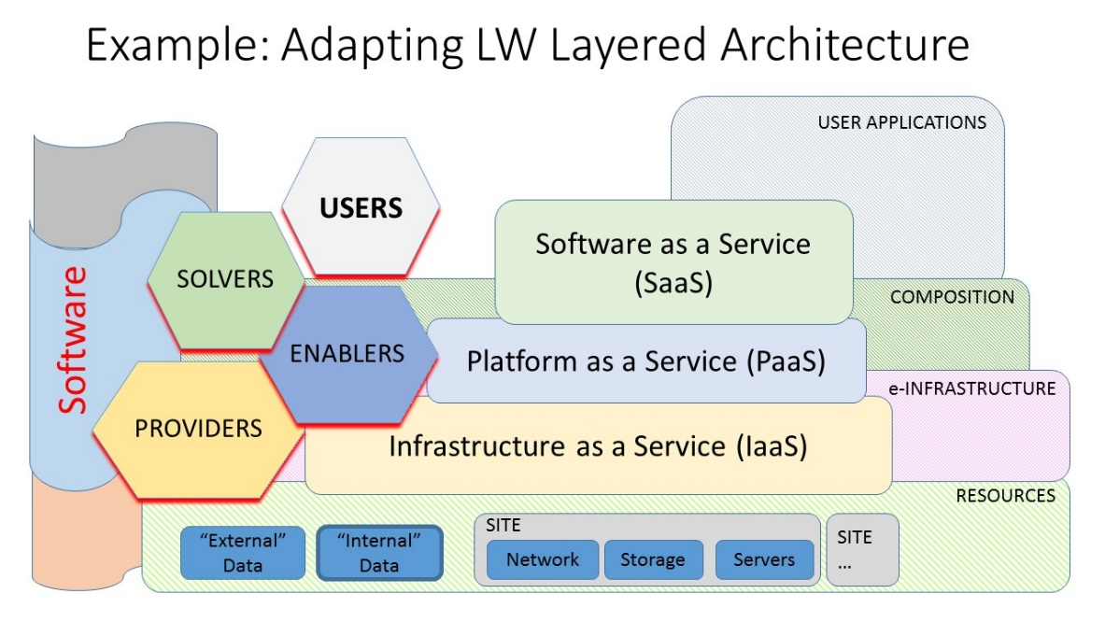
Another important point is the roles of the actors in these structure, an example:
• Service providers (like EGI FedCloud for IaaS)
• Enablers (to exploit the services, including if needed extra services/tools)
• Solvers (providing solutions to the final user, integrating “specific” knowledge)
• Users
The software components, at all levels, are a relevant part of all the services, and must not be forgotten in the Cloud scheme (have this in mind for the definition of services!!!)

A catalogue of services related to EU e-infrastructures
The list includes (see summary table):
• EGI.eu: HTC (mainly Grid), Cloud (FedCloud, EGI DataHub?)
• GEANT: Network, Common AA (?), Aggregation (eg. Cloud providers)
• PRACE: Supercomputing
• EUDAT: (Big) Data (+ preservation?)
• OpenAIRE: Open Access (information, data?) support, DOIs and PIDs
• INDIGO-DataCloud (IaaS, PaaS and SaaS oriented software)

A table indicating some of the services in their catalogues:
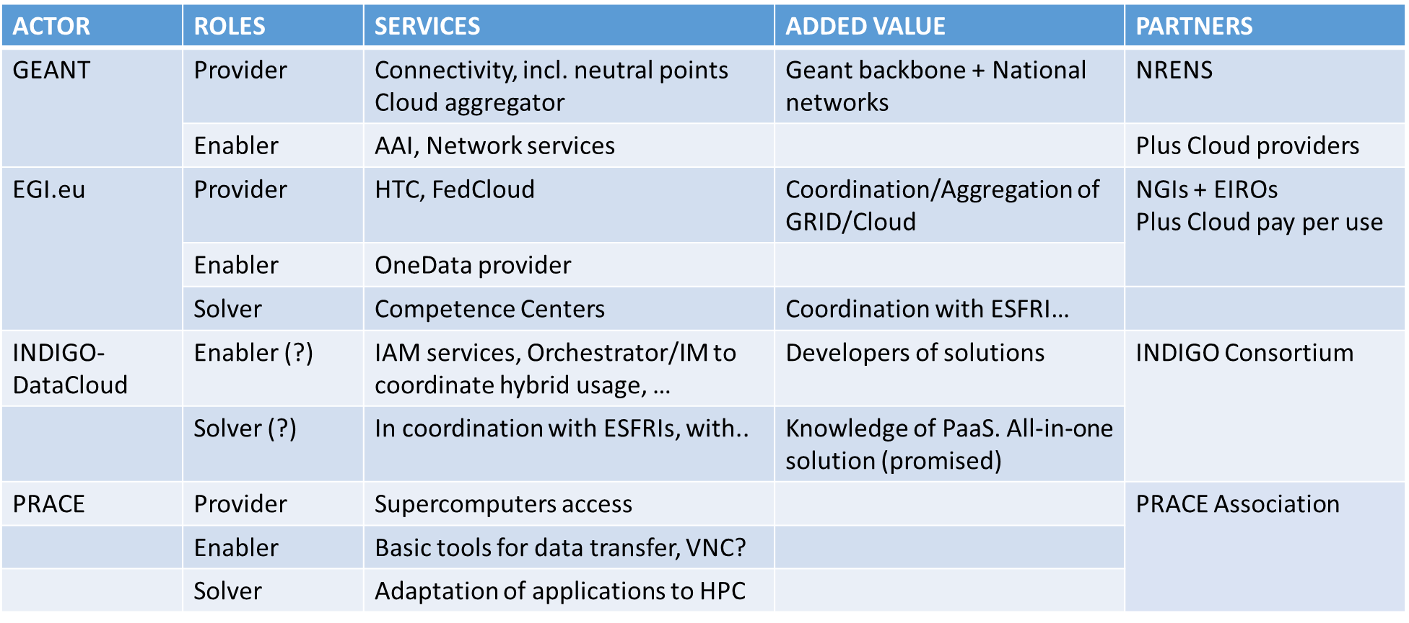

A detailed example
The following example describing the Algae Bloom application following a layered Cloud structure and identifying all the components:

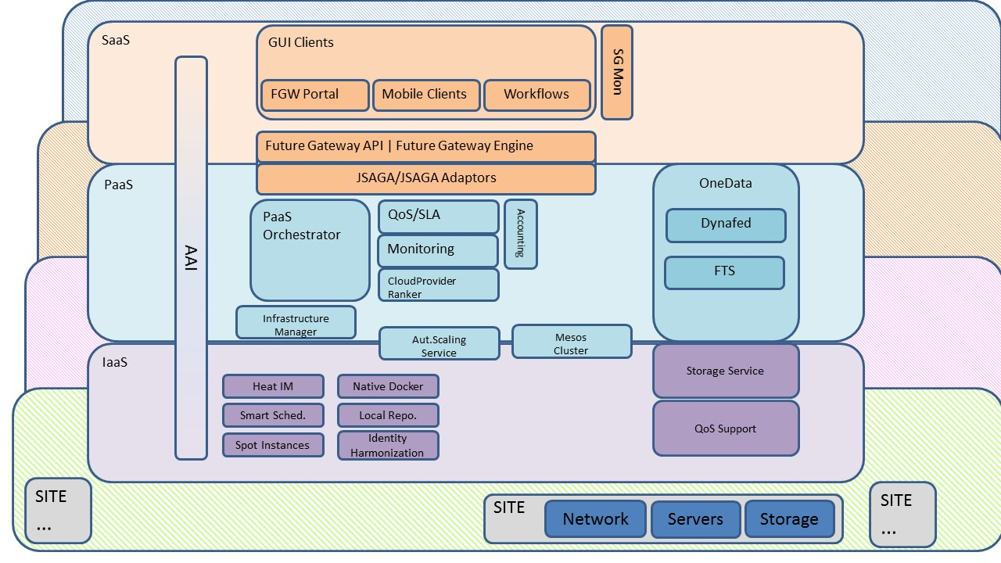
- Services description

Introducing a template
The template is based in FitSM description of services
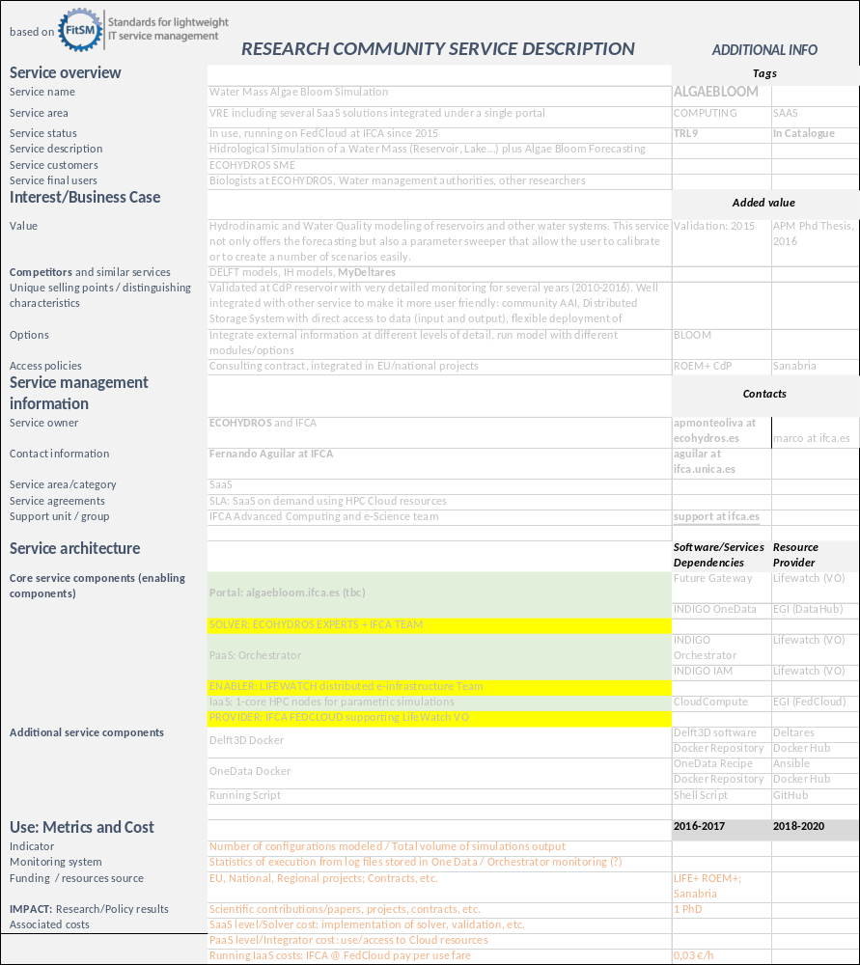

Summary of common features in the different services
The templates are presented in Appendix 1
The following common features are identified:
-Use of IaaS?
-PaaS tools?
-
-integration of external software?
- Service architecture (check previous deliverable, rewrite)
In this section we make an attempt to define a common architecture to offer R execution services. The architecture is based on EGI HTC/HPC resources to provide a scalable execution platform for large communities and large use cases. The service architecture provides an overview of the key (logical) service components and their dependencies to help better understand the structure and logical as well as technical setup of the service.

High-Level Service architecture oriented to the Cloud framework
The following schema shows the proposed architecture defined to include R services within EGI Federated Cloud and link them with external resources if needed:
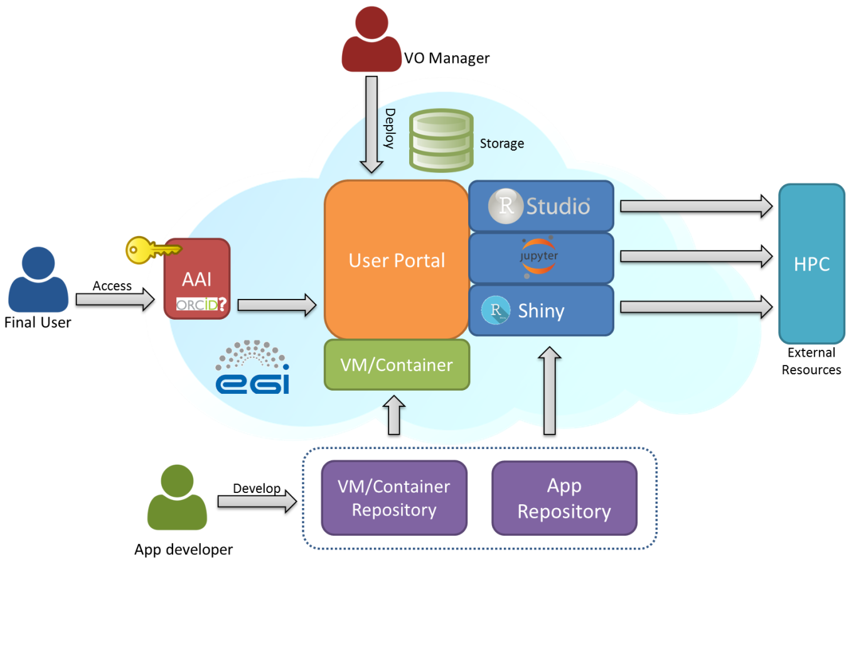
Figure 1 – Service Architecture oriented to the EGI Cloud
The proposed architecture includes three different roles for interacting with the system: VO Manager, App developer and Final User. The Virtual Organization Manager is the person who takes care of the different managerial tasks from the research community side, in this case, of the management of the Lifewatch Virtual Organization (vo.lifewatch.eu). This person authorizes new users in the organization, that will be allowed to access to the services offered by the infrastructure, and he/she is also the responsible of deploying and administrating general and long term services, like the LifeWatch project management system, GIS servers or R services. The second role, App developer, groups all the IT members who are in charge of developing and eventually deploying new services in the LifeWatch environment such as Virtual Machines or Containers with pre-defined web services, applications based on tools like R shiny, workflows, scripts for Jupyter, etc. The last role, Final User, corresponds to researchers (including biologists but also other with different technical profiles) that consume the resources provided by the infrastructure accessing to the web services: R Shiny final apps, RStudio server, Jupyter notebooks, and also other related tools like GIS or predefined python workflows, etc. The Final User role could also include citizen scientists with access to certain services.
Regarding the AAI (Authorization and Authentication Infrastructures) component, we need a standardized solution to allow different type of final users to access to the infrastructure. Within EGI infrastructure, some solutions are being developed and LifeWatch requirements have been communicated through the specific AARC project, where EGI is one of the partners. For researchers, one of the possible solutions is accessing through ORCID credentials, linked to their host institutions. For citizen scientist, an OpenID or similar solution could work. Once the user is logged in, he/she would be able to access to the web services, using local storage or remote cloud storage, and access to collaboration data, including open data, via federated resources, as being explored in the Data Commons solutions. R services are very oriented to data analysis, so that an optimal access to data is key, and it should be closer enough to the computing. That is why users need a storage space accessible by the R services that can be owned by them or by the group that they belong to.
A key component of the architecture is the User Web Portal where the services are published. These services are deployed at sites that provide resources to EGI FedCloud supporting LifeWatch VO. Different types of R services (one or more in each portal) can be published: RStudio server, Rshiny or Jupyter, all of them previously described in section 3. This web portal is implemented in a Virtual Machine (or Container) that can also run over EGI FedCloud infrastructure.
The services could also be extended to access external HTC/HPC resources (accessed either through ‘grid’ or ‘cloud’ interfaces), using specific packages, as explained later. Permanent and general use web portals are deployed by the VO Manager, while temporal services can be deployed by app developers or by final users with LifeWatch VO credentials.

App developers will mainly handle two types of resources: Virtual Machines and Containers predefined to be launched OR Applications based on other services, like Rshiny. Virtual Machines or containers are a set of packaged services ready to be launched in the EGI FedCloud infrastructure and that can be managed via a repository like EGI AppDB. The development of applications based on services like R shiny, what is very focused on providing R access using web interfaces, can also require a git repository that could be deployed directly in connection with the corresponding web portals.
Finally, certain R services could require not only local resources but also external HPC resources. In such cases R must be installed in the external resource with specific libraries enabling remote R computing, as explained later.

Challenges
There are some elements of the architecture that need to be integrated with others to be completely functional: AAI, access to external resources, access to storage and access to repositories.
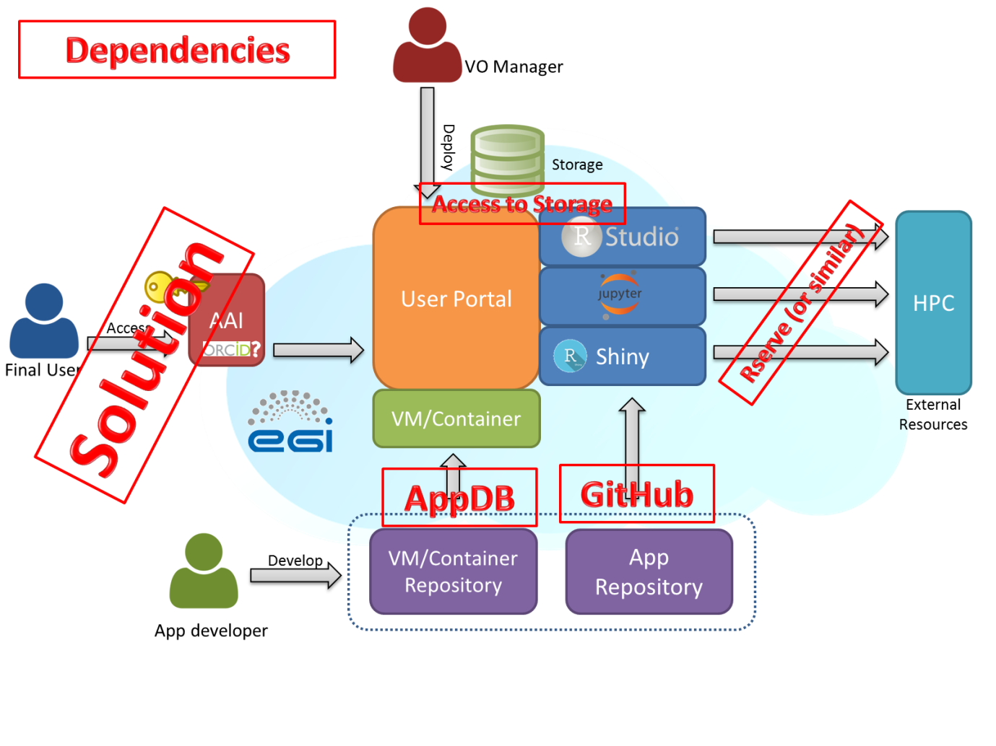
Figure 2 – Service Architecture: Dependencies

AAI
For AAI, as previously indicated, EGI is working on providing a general solution for certain type of users, like a SSO (single sign-on) solution for accessing services. This development is ongoing in the the JRA1.1 task of the EGI-Engage project. This work aims at a pilot system that would
- Simplify the process of connecting EGI services (e.g. AppDB, Operations Portal, GOCDB, etc.) with AAI architectures operated by external infrastructures, such as LifeWatch.
AND
- Harmonise the integration of EGI services across multiple, externally operated RI AAIs. (e.g. AppDB would be connected to the LifeWatch AAI, the DARIAH AAI, the ELIXIR AAI in a harmonised way).
The design of this new EGI AAI pilot system has finished in 2015 in close collaboration with the AARC H2020 project . In the heart of the pilot system there is an ‘IdP/SP Proxy’ component, which is based on SAML technology. The IdP/SP Proxy will be responsible for mapping an external user identity to an ‘EGI identifier’ which will be used for the same user across all the EGI services. The IdP/SP Proxy will be able to import attributes from external attribute authorities (e.g. from LifeWatch IdPs) and assign these to the internal EGI user identifier. Based on the imported attributes the EGI services can authorise users across the whole EGI network in a coherent way.
Another relavant development in EGI is the recently established ‘Long-tail of science platform’, and particularly its user registration and authorization system. In this platform a ‘User Registration Portal’ serves for users to request access to the infrastructure. After a user request is approved, the allocated capacity can be accessed trough any of the scientific gateways (VREs) that are connected to the platform. The gateways use robot certificates with a special extension to separate users, and to allow complete tracking of user activities at the lower levels of the infrastructure.

The R community is pretty active on developing new packages that enrich the features of a basic R installation. As indicated before, the Rserve package enables consuming resources from an external R installation, i.e. using external computational capacities. To do so, R must be installed in both resources (client and server) as well as Rserve packages: the client needs to query the server and the server must be able to get that request, compute it and return a result. This system can be used to consume external HPC resources. There are other interesting solutions like the option provided in RStudio Server Pro, which is able to manage load balancing using different computing nodes, but unfortunately this is not available as an open source solution yet.

Access to data
Regarding the critical access to data storage, we could use a distributed storage solution, like LUSTRE or GPFS, deploying a global file system. In such case, every R server needs to be able to access to that global file system, and it needs to be flexible enough to accept new clients, or mount the corresponding volume with the well known security problems. As indicated before, within this EGI-Engage project and under the development of Data Common, EGI is testing a general solution for distributed storage based on OneData (https://onedata.org/). This solution is a very good option to be used within the LifeWatch framework.

Repositories
Finally, the last dependencies to be considered are related to repositories. Virtual Machines or Containers can be stored in AppDB by EGI, so the link between the repository and the infrastructure is direct. However, a customized deploying system needs to be developed to work with application repositories, like GitHub. This deployment can be addressed at the time of setting up the VM/container or later on, after launching it.
- Monitoring/Impact/Feedback on satisfaction?
In this section we report briefly on the positive, although yet limited, experience with the use of the R tools described before. Part of the work presented here has been done under different initiatives closely related to LifeWatch.

Experience at IFCA
The option explored to run the R scripts by the final user (D.G. working for Ecohydros SL) was the use of Jupyter notebooks. As indicated before, notebooks are organized in different cells, so users can work in different parts separately and wrote the script in different parts and then check one by one if there is any error. This option was considered quite useful by D.G.
As an example, when executing the theRmocline.R script, all necessary parameters are first checked and then the fit of the simulated thermocline versus the actual data is done (see below).

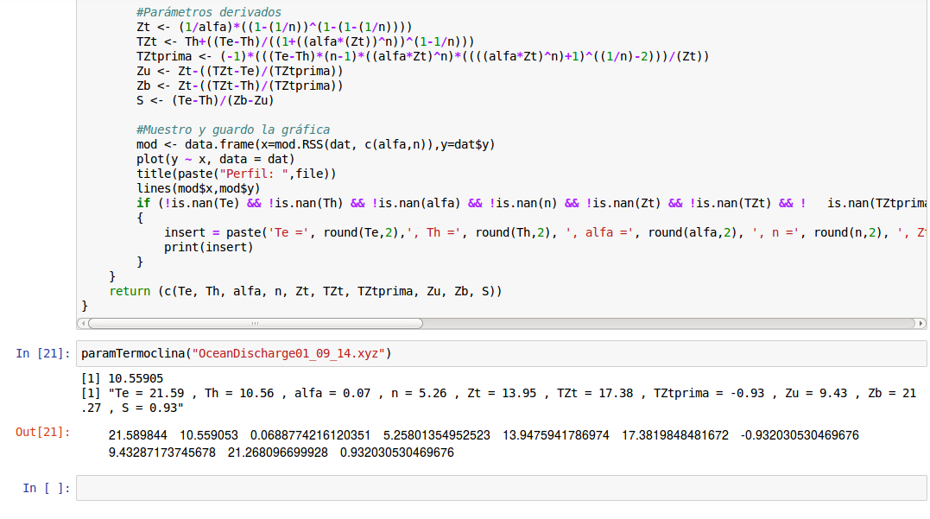
Figure 3 – Execution of an R script in a Jupyter notebook
The script has two versions: one reading data from CSV files and another one using directly the database, via the RMySQL package. If this script is used only to fit a single thermocline, there is not much difference versus using a workstation at the office. However, as many files corresponding to the output of different models were to be compared with the data taken each day along the hydrological year (around 300 vertical profiles), the computation time was significantly reduced.
The main advantage to work with Jupyter notebooks and R instead of using Excel (the usual solution in the company for data analysis) is the option to automate the process of uploading many different files and calculating all the fit parameters in one round. Another important advantage is that the script exports the results from the study and the charts and automatically saves them in pdf format, completing the whole process.

Experience at VLIZ
The Lifewatch data explorer tool has been already tested by several project partners, and their feedback has largely been implemented. A training workshop will be organized in the next couple of months.
The system suffers from performance issues when dealing with very large datasets, and some measures have been taken to compensate for this. The main problem is on the client side (the browser), so we moved more of the processing load to the server where R is able to handle higher demands. How the servers ‘scale’ when more users get involved is uncertain for now. Mirroring, clustering, load balancing the servers is possible, but not a priority at this stage.

Experience at HCMR
Rvlab has been tested in numerous workshops and training courses including the EMBOS workshop in Crete, 2014 (https://www.lifewatchgreece.eu/?q=content/embos-synthesis-meeting-0), the Lifewatch data analysis workshop (biodiversity data preparation and analysis using the Lifewatch virtual labs and web services) in VLIZ, 2015 (http://lifewatch.be/en/lifewatch-data-analysis-workshop) as well as other meetings and conferences.
- Summary
The described services are currently deployed both in local resources (that can be linked to EGI FedCloud environment) and in external sites that support Lifewatch Virtual Organization. In the last months a new site integrated with EGI FedCloud has been deployed in “Estación Biológica de Doñana”, placed at Seville, Spain. This site will serve as the main site providing resources to the Lifewatch Virtual Organization, including both central services and user-oriented services, like Geographical Information Systems, Databases, Data Catalogues or computing-analysis services based in different technologies like R. That is why in the near future the distributed services that are very important for Lifewatch users will be installed at EBD site, including those explained in the previous sections.
The features provided and the infrastructure deployed at Seville, will increase the interest on joining the LifeWatch Virtual Organization. For instance, Seville site has deployed a large NFS system that can store data from users and connect to the computing part based on Cloud in a faster way. Also, this NFS system can be integrated with the OneData Solution that is being tested by EGI as a distributed storage solution.
In parallel, in the framework of the LifeWatch EGI-CC, several working groups have been established in the past meeting at Bari EGI Conf 2015, and one of them lead by HCMR and with the collaboration of VLIZ and IFCA teams, will address the support to R solutions. This work is now being tracked using the OpenProject web tool, that has been selected by LifeWatch as the basic support tool for its distributed e-infrastructure project, and in this way we expect to collect in the next months the requirements of more Case Studies, analyze them and create the corresponding backlog focused on R services.
Also the work on the integration of an EGI AAI solution has already started, in connection to the AARC initiative.
Finally, and as clearly indicated in the example of VLIZ marine observatory, a global framework for the development and use of the different tools and services is already implemented: the LifeWatch Marine Virtual Research Environment (LW Marine VRE, see http://marine.lifewatch.eu/ ). The LifeWatch EGI-CC will support this development as well as the ongoing similar effort on other areas (Non-marine VRE).

Appendix: Templates for the services
R can be installed in many different infra

First report and recommendations of the Commission High Level Expert Group on the European Open Science Cloud, doi:10.2777/940154
See https://wiki.egi.eu/wiki/CC-LifeWatch_Community
For a complete overview see: A. Monteoliva, PhD Thesis, Feb 2016 (in press)
DELFT3D: see http://oss.deltares.nl/web/delft3d
Authentication and Authorisation for Research Collaboration, AARC, see https://aarc-project.eu/
https://wiki.egi.eu/wiki/EGI-Engage:WP4#TASK_JRA2.1_Federated_Open_Data
At the time of writing AppDB already supports VMs, but does not (yet) supports containers. Containers can be manually deployed into VMs, for example as described at https://wiki.egi.eu/wiki/Federated_Cloud_user_support#Docker_containers.
https://wiki.egi.eu/wiki/EGI-Engage:WP3#TASK_JRA1.1_Authentication_and_Authorisation_Infrastructure
https://wiki.egi.eu/wiki/Long-tail_of_science

